

**Placement Empowerment Program**

**Cloud Computing & DevOps Center**

**Host a static website locally:** Set up a local server (Apache or Ngnix) and host a simple HTML page

**Name:** Prasanna Krishna B

**Dept:** IT

**Reg number:** 312323205171

**INTRODUCTION**

Setting up a local server using Apache or Nginx allows developers to host and test web applications in a controlled environment before deploying them online. Apache and Nginx are popular web servers known for their reliability, flexibility, and performance. To get started, install the chosen server on your system and configure it to serve a basic HTML page. This involves setting up the necessary directories, placing an HTML file in the designated web root folder, and starting the server to make the page accessible via a local URL.

**Step-by-step process:**

**Step 1:** In your browser (can be any) search “APACHE LOUNGE”.

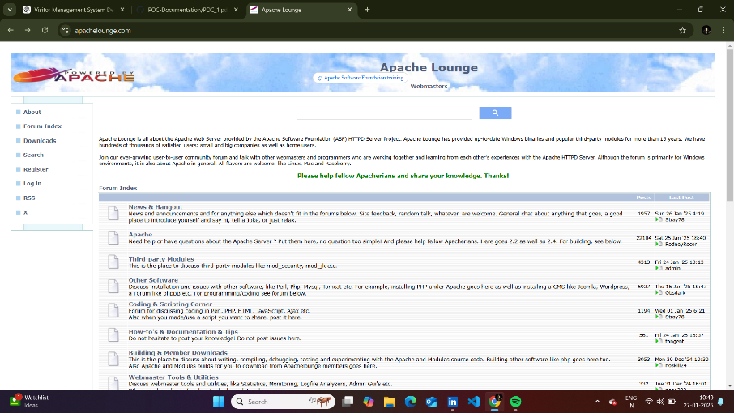

**Step 2:** Go to the “DOWNLOADS” column in the sidebar and click on it.



**Step 3**: Select the latest version and click on download.

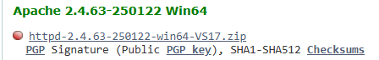

Step 4: Open the “CMD PROMPT” and run it as ADMINISTRATOR”.

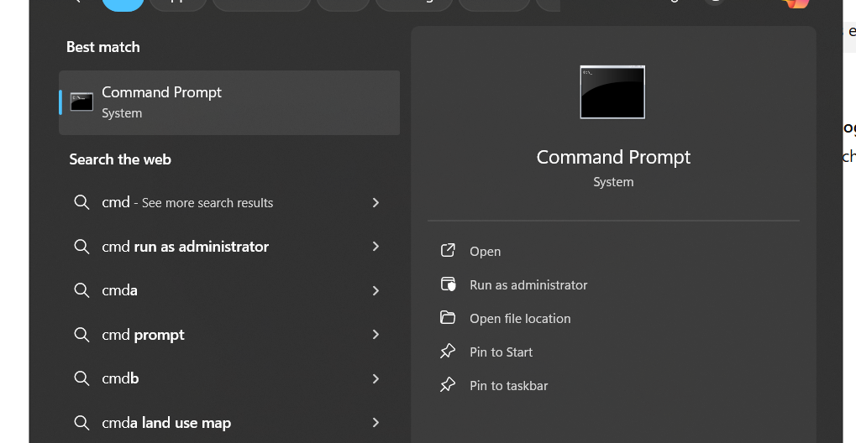

**Step 5**: For setting up the Apache server run the following commands**.**

**Cmd 1**: Setting the path to the Apache bin.

“C:\Apache24\bin”

**Cmd 2:** Then run the installation cmd.

“httpd.exe -k install”

**Cmd 3**: TO check whether the Apache is installed.

“httpd.exe -t”

**Cmd 4:** To start the Apache server.

“httpd -k start”

**Cmd 5**: To restart the server.

“httpd -k restart”

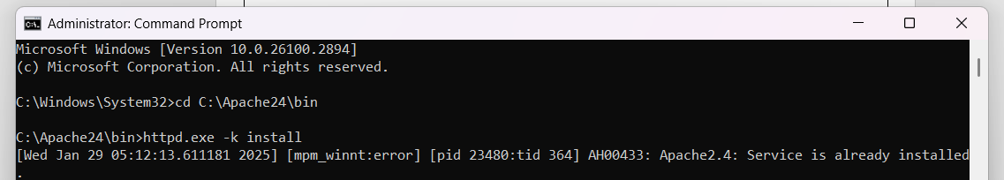







**Step 6:** Now go to the “CONFIG” folder and open the httpd.config, and make few changes in it. (Open it in Notepad)

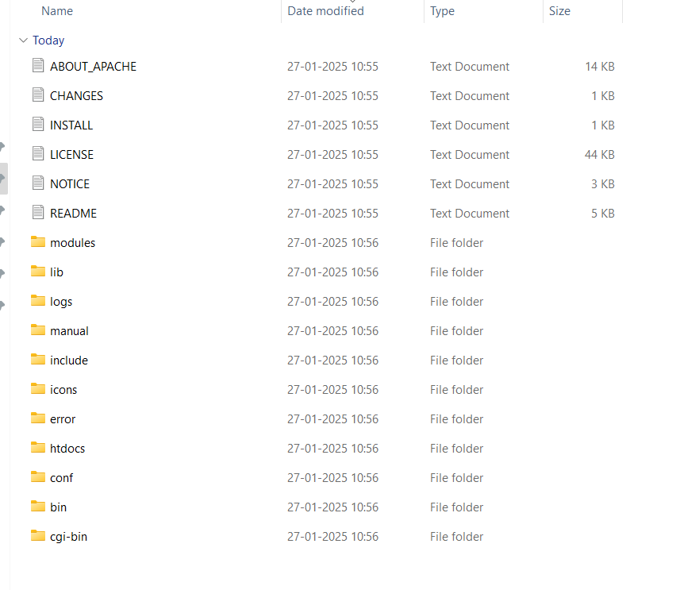

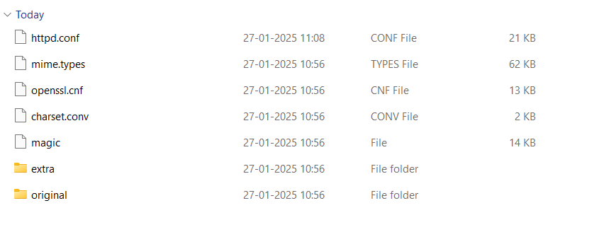

**Change 1:** In the “DIRECTORY”.

<Directory "C:/myweb">

Options Indexes FollowSymLinks

AllowOverride None

Require all granted

</Directory>

**Change 2:** In the “DOCUMENTROOT”.

DocumentRoot "C:/myweb"

**Step 7:** Open the httd.dcos folder and in that open “index.html” and update your “HTML” code.

**Step 8:** Open the browser and type <http://localhost:80> to navigate to your HTML page.

**TESTING**

* This is the default test page for Apache or Nginx web servers, indicating that the server has been successfully set up and is running.
* If you're seeing this page after configuring your local server, it means your setup is working correctly, and your server is serving web pages as expected.

